Jake Orben

CSC 325

September 18, 2013

List of 4 bit counters and how they work

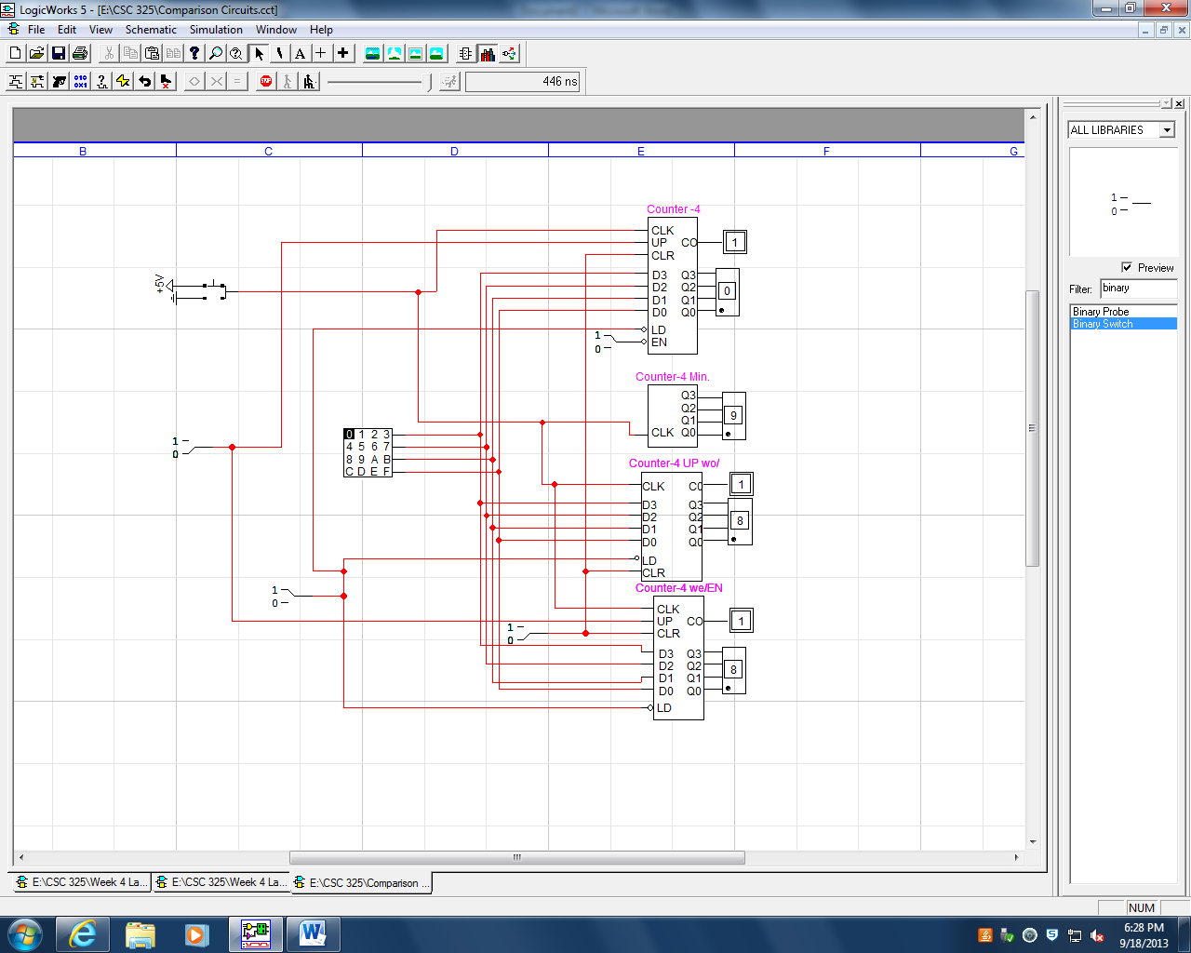

Counter-4

Counts from 0-15

Clock - toggles the count and, if Load is enabled the clock will load from the keyboard

UP – changes the direction of the count from forwards to backwards

LD – is asserted low and selects if the keyboard should be loaded from

EN – enables the counter and is asserted low

D0-D3 data input from keyboard

CLR – clears data in the hex out

CO – carry out, deals with overflow data, adds a 5th bit

Q0-Q3 – used as the current value for the hex keyboard

**Counter-4 Min.**

Counts from 0-15

Clock toggles count

**Counter-4 UP wo/EN**

Counts from 0-15

Clock - toggles the count and, if Load is enabled the clock will load from the keyboard

D0-D3 data input from keyboard

CLR – clears data in the hex out

CO – carry out, deals with overflow data, adds a 5th bit

Q0-Q3 – used as the current value for the hex keyboard

LD – is asserted low and selects if the keyboard should be loaded from

**Counter-4 wo/EN**

Counts from 0-15

Clock - toggles the count and, if Load is enabled the clock will load from the keyboard

UP – changes the direction of the count from forwards to backwards

D0-D3 data input from keyboard

CLR – clears data in the hex out

CO – carry out, deals with overflow data, adds a 5th bit

Q0-Q3 – used as the current value for the hex keyboard

LD – is asserted low and selects if the keyboard should be loaded from

UP – changes the direction of the count from forwards to backwards